Paper不会那么细
Make this tool for other ppl for freely available
“hey we have a new tool” 这是发ds的paper – 写一个
画流程图
画几个大的和小的
To have a readme.file
Most really is gonna be a paragraph
The dataset consisted of 13,990 sleep records from approximately 10,000 participants, including self-reported sleep onset latency (SOL) and wake after sleep onset (WASO) durations (duration_totalmin_sol_estimate_am and duration_totalmin_waso_estimate_am), self-reported estimates for time in bed(time_bed_am), time falling asleep(time_sleep_am), time waking in bed,( time_awake_am) and time getting out of bed(time_getup_am). As these records were manually entered, a programmatic correction pipeline was implemented to adress input errors, which included processing of both time durations and timestamps as well as calculation of sleep intervals based on those self-reported estimates. The overall ipeline is implemented by running ???
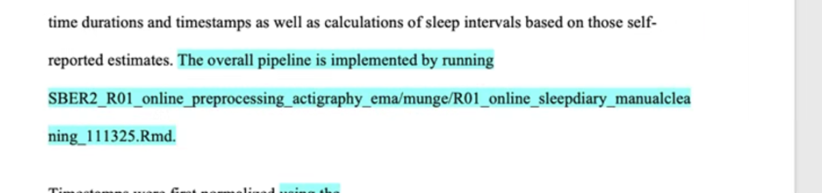
Timestamps were first transformed into a standard format using the script process_timestamp_emadatarelease.R, which iteratively applied the function process_timestamp() to each variable in the vector tstamp.vars.to.proc. For efficiency and memory management, a pre-allocated vector was used to store standardized time strings. Columns containing entirely illogical data, such as logical vectors, were converted to NA_character_. Columns of type hms or difftime were reformatted to the "HH:MM" character format, and all other types were coerced to character strings, ensuring robust type safety and preventing silent errors during downstream processing. “Nonstandard strings such as "H:MM" or "H" were converted to "0H:MM" or "0H:00", substantially mitigating misalignment errors during conversion to time vectors, e.g., 15 minutes misinterpreted as 15 seconds ("00:15")
What is it that we are doing
Find a paper in data science and read it
划线部分在tool box， 但是paper说的是形容这个tool是什么function
Sleep restriction worsens mood and emotion regulation
Following type standardization, each row was processed to normalize string representations of time, replacing delimiters such as periods and semicolons with colons. Above steps mitigated frequent misalignments caused by converting character strings to time vectors, such as minutes being erroneously interpreted as seconds. With the prepartion step of hours and minutes were then extracted, a further correction loop adjusted PM hours in 24-hour representations by subtracting 12 hours when appropriate. Special handling was applied for evening variables, time_bed_am and time_sleep_am, at midnight. Specifically, when a variable was marked PM, the hour equaled 12, and the timestamp was not in 24-hour format, the hour was retained as 12 and the AM/PM designation was corrected to "AM" to avoid misrepresentation or zero values. Additional error flags captured values exceeding valid ranges and atypical patterns, such as evening hours less than six labeled as AM, and all remaining anomalies were recorded in dedicated columns ("xxx_h_othererrors") for systematic verification.
This approach ensured that all timestamp variables were consistently formatted, computationally safe, and annotated with potential errors, providing a reliable basis for subsequent sleep interval calculations and longitudinal analyses.

The algorithm involved taking in 4 variables, we are looking for calculating xx, in a way we wanted to makesure it is withing normal physiological reason， in a rool to detect those thresholds, if outside of that we neeed manual checking, these cases xxx need, these cases xxx

